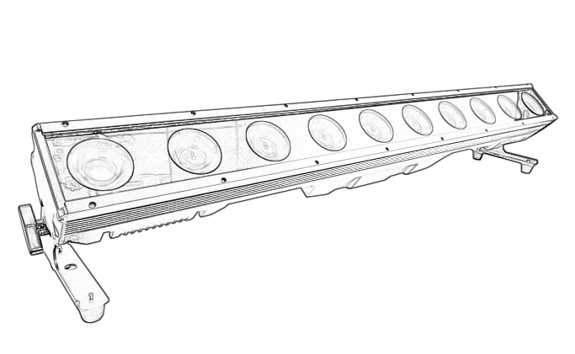
User manual

IP-PIX500
Please read the instructions carefully before use

TABLE OF CONTENTS
- Safety Instructions………………………………………………………………………………3
- Technical Specifications…………………………………………………………………………4
- Control Menu ……………………………………………………………………………………4-6
- DMX Channel ……………………………………………………………………………………6-10
- Dimension………………………………………………………………………………………11-12
- Trouble Shooting…………………………………………………………………………………13
- Fixture Cleaning………………………………………………………… ………………………13

STATEMENT
The product has well capability and intact packing when leave factory. All of the user should comply with warning item and manual, any misuse cause of the damages are not included in our guarantee, and also can not be responsible for any malfunction & problem owing to ignore the manual.

1.Safety Instructions
Please keep this User Guide for future consultation. If you sell the unit to another user, be sure that they also receive this instruction booklet.
•Unpack and check carefully there is no transportation damage before using the unit.
•Before operating, ensure that the voltage and frequency of power supply match the power requirements of the unit.
•It’s important to ground the yellow/green conductor to earth in order to avoid electric shock.
•The unit is for indoor use only. Use only in a dry location.
•The unit must be installed in a location with adequate ventilation, at least 50cm from adjacent surfaces. Be sure that no ventilation slots are blocked.
•Disconnect main power before replacement or servicing.
•Make sure there are no flammable materials close to the unit while operating as it is fire hazard.
•Use safety cable when fixes this unit. DO NOT handle the unit by taking its head only, but always by taking its base.
•Maximum ambient temperature is Ta: 40℃. DO NOT operate it where the temperature is higher than this Unit surface temperature may reach up to 85℃. DO NOT touch the housing bare-hand during its operation. Turn off the power and allow about 15 minutes for the unit to cool down before replacing or serving.
•the event of serious operating problem, stop using the unit immediately.Never try to repair the unit by yourself. Repairs carried out by unskilled people can lead to damage or malfunction. Please contact the nearest authorized technical assistance center. Always use the same type spare parts.
•DO NOT touch any wire during operation as high voltage might be causing electric shock.
Warning:
•To prevent or reduce the risk of electrical shock or fire, do not expose the unit to rain or moisture.
•The housing, the lenses, or the ultraviolet filter must be replaced if they are visibly damaged.
Caution:
•There are no user serviceable parts inside the unit. DO NOT open the housing or attempt any repairs yourself. In the unlikely event your unit may require service, please contact your nearest dealer.
Installation:
•The unit should be mounted via its screw holes on the bracket. Always ensure that the unit is firmly fixed to avoid vibration and slipping while operating. And make sure that the structure to which you are attaching the unit is secure and is able to support a weight of 10 times of the unit’s weight. Also always use a safety cable that can hold 12 times of the weight of the unit when installing the fixture.
•The equipment must be fixed by professionals. And it must be fixed at a place where is out of the touch of people.

2.Technical Specifications
Light source:10*50W RGBW 4in1 Led or CW+WW 2in1 LED
Led pixel control effect
Four side of bar can be freely spliced
Max consumption Power: 400W
Beam angle:40°(15°/25°optional)
DMX Channel:9/49/40CH
Control: DMX512/Auto Run/Master-Slave/Music/RDM
Display:LCD display
IP Rate: IP65
Strong aluminum housing and IP65 cooling fan
Rich build-in color & pattern Marco effect
Seetronic power & XRL in/out waterproof socket
Omega quick lock system brackets
Dimension:1000*100*85mm;
NW:8.55KG
Optional accessories:
①.Filter; ②, floor base; ③.hanger bracket;④: hooks

3.Control Menu
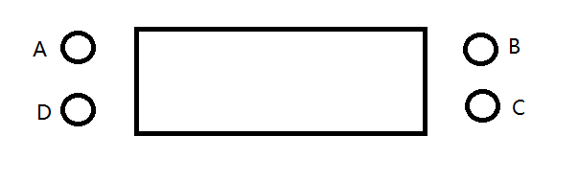

Display:
A．function key
B．add key
C．reduction key
D. determine key
LCD Display Function （Press and hold the determine button for 1-2 seconds on any of the following interfaces to display the temperature. Restore the current interface after releasing it）
（Password：function key-add key-reduction key-determine key）

NO. | Main menu | Function | Note
1 | DMX_09/49/40CH  A:001 | Channel Address Code | Default:001  range :001—512  Attention: When receiving the DMX signal, the "_" interval in the first line of display flashes
2 | DMX_CH  xxCH | Channel Mode | Default:09  xx:09/49/40
3 | Marco*00  Speed 00 | Running Effect  Running Effect Speed | Default:00 range :00-45  Default:00 range :00-99  * become -:mean the item is selected
4 | Q-Sense  S:50 | Voice sensitive value – front desk | Default:50  range :00-50
5 | Red  R:255 | Static Red | Default:255  range :000-255
6 | Green  G:255 | Static Green | Default:255  range :000-255
7 | Blue  B:255 | Static Blue | Default:255  range :000-255
8 | White  W:255 | Static White | Default:255  range :000-255

LCD Background Display Function（Press and hold the function key for 6-8 seconds to enter the DMX mode, and press the determine key to exit）

No. | Menu | Function
1 | Current R:180 | Red’s current, Default (180) range （020—255）
2 | Current G:235 | Green’s current, Default (235) range （020—255）
3 | Current B:235 | Blue’s current, Default (235) range （020—255）
4 | Current W:235 | White’s current, Default (235) range （020—255）
5 | Power D:160 | Total power limit, Default (160) range （050—255）
6 | Push YSE/NO | Push back end data, Default (NO)  NO: Do not push back end data to the slave  YES: Push back end data and update back end parameters of the slave machine  Attention: When pushing, the signal line between the host and the slave should be connected and powered on, and the slave should now have a DMX address interface. When the host is pushing data, do not be in a hurry to exit. Wait for the slave light to flash to indicate successful updates before exiting.
7 | Time D:55 | Temperature control settings  Default (55) range :（40—70）  Attention: The lamp body needs to be connected to a temperature control resistor before the temperature control can function.
8 | D-State HOLD/OFF | The state of lamp after loss of the DMX512 signal(hold or turn off) , Default (OFF)
9 | D-Bit D:8/16 | Dimming Bit Default (16)  When the dimming is 16bit, the light bead changes smoothly; When it is 8bit, the light bead changes steeply.
10 | Lock ON/OFF | Combination lock Default (ON)  Touch exclusive lock to prevent accidental touch and action.
11 | B-Sense S:30 | Voice sensitive value – background  Default (30) range : (00-50)

4.DMX Channels
9 Channel
Channel | Function | DMX Value | Description
1 | Total dimming | 0 - 255 | Linear dimming.  From dark to bright, controlling full color
2 | Strobe | 0-5 | empty
2 | Strobe | 6- 255 | From slow to fast
3  3 | Macro Function  Macro Function | 0－5 | empty
3  3 | Macro Function  Macro Function | 6－10 | Gradient
3  3 | Macro Function  Macro Function | 11－15 | Pulse
3  3 | Macro Function  Macro Function | 16－20 | Jump
3  3 | Macro Function  Macro Function | 21－25 | pattern1
3  3 | Macro Function  Macro Function | 26－30 | pattern2
3  3 | Macro Function  Macro Function | 31－35 | pattern 3
3  3 | Macro Function  Macro Function | 36－40 | pattern 4
3  3 | Macro Function  Macro Function | 41－45 | pattern 5
3  3 | Macro Function  Macro Function | 46－50 | pattern 6
3  3 | Macro Function  Macro Function | 51－55 | pattern 7
3  3 | Macro Function  Macro Function | 56－60 | pattern 8
3  3 | Macro Function  Macro Function | 61－65 | pattern 9
3  3 | Macro Function  Macro Function | 66－70 | pattern 10
3  3 | Macro Function  Macro Function | 71－75 | pattern 11
3  3 | Macro Function  Macro Function | 76－80 | pattern 12
3  3 | Macro Function  Macro Function | 81－85 | pattern 13
3  3 | Macro Function  Macro Function | 86－90 | pattern 14
3  3 | Macro Function  Macro Function | 91－95 | pattern 15
3  3 | Macro Function  Macro Function | 96－100 | pattern 16
3  3 | Macro Function  Macro Function | 101－105 | pattern 17
3  3 | Macro Function  Macro Function | 106－110 | pattern 18
3  3 | Macro Function  Macro Function | 111－115 | pattern 19
3  3 | Macro Function  Macro Function | 116－120 | pattern 20
3  3 | Macro Function  Macro Function | 121－125 | pattern 21
3  3 | Macro Function  Macro Function | 126－130 | pattern 22
3  3 | Macro Function  Macro Function | 131－135 | pattern 23
3  3 | Macro Function  Macro Function | 136—140 | pattern 24
3  3 | Macro Function  Macro Function | 141—145 | pattern 25
3  3 | Macro Function  Macro Function | 146—150 | pattern 26
3  3 | Macro Function  Macro Function | 151－155 | pattern 27
3  3 | Macro Function  Macro Function | 156－160 | pattern 28
3  3 | Macro Function  Macro Function | 161－165 | pattern 29
3  3 | Macro Function  Macro Function | 166－170 | pattern 30
3  3 | Macro Function  Macro Function | 171－175 | pattern 31
3  3 | Macro Function  Macro Function | 176－180 | pattern 32
3  3 | Macro Function  Macro Function | 181－185 | pattern 33
3  3 | Macro Function  Macro Function | 186—190 | pattern 34
3  3 | Macro Function  Macro Function | 191—195 | pattern 35
3  3 | Macro Function  Macro Function | 196—200 | pattern 36
3  3 | Macro Function  Macro Function | 201－205 | pattern 37
3  3 | Macro Function  Macro Function | 206－210 | pattern 38
3  3 | Macro Function  Macro Function | 211－215 | pattern 39
3  3 | Macro Function  Macro Function | 216－220 | pattern 40
3  3 | Macro Function  Macro Function | 221－225 | pattern 41
3  3 | Macro Function  Macro Function | 226－230 | pattern 42
3  3 | Macro Function  Macro Function | 231－235 | pattern 43
3  3 | Macro Function  Macro Function | 236—255 | sound
4 | Macro function speed | 0 - 255 | From slow to fast
5 | R dimming | 0 - 255 | Linear dimming.  From dark to bright, controlling Red color
6 | G dimming | 0 - 255 | Linear dimming.  From dark to bright, controlling Green color
7 | B dimming | 0 - 255 | Linear dimming.  From dark to bright, controlling Blue color
8 | W dimming | 0 - 255 | Linear dimming.  From dark to bright, controlling White color
9  9 | Background color  Background color | 1-32 | Red
9  9 | Background color  Background color | 33- 64 | Green
9  9 | Background color  Background color | 65- 96 | Blue
9  9 | Background color  Background color | 97-128 | White
9  9 | Background color  Background color | 129-160 | Yellow
9  9 | Background color  Background color | 161-192 | pink
9  9 | Background color  Background color | 193-224 | cyan
9  9 | Background color  Background color | 225-255 | rgbw
49 Channel
Channel | Function | DMX Value | Description
1 | Total dimming | 0 - 255 | Linear dimming.  From dark to bright, controlling full color
2 | Strobe | 0-5 | empty
2 | Strobe | 6- 255 | From slow to fast
3  3 | Macro Function  Macro Function | 0－5 | empty
3  3 | Macro Function  Macro Function | 6－10 | Gradient
3  3 | Macro Function  Macro Function | 11－15 | Pulse
3  3 | Macro Function  Macro Function | 16－20 | Jump
3  3 | Macro Function  Macro Function | 21－25 | pattern1
3  3 | Macro Function  Macro Function | 26－30 | pattern2
3  3 | Macro Function  Macro Function | 31－35 | pattern 3
3  3 | Macro Function  Macro Function | 36－40 | pattern 4
3  3 | Macro Function  Macro Function | 41－45 | pattern 5
3  3 | Macro Function  Macro Function | 46－50 | pattern 6
3  3 | Macro Function  Macro Function | 51－55 | pattern 7
3  3 | Macro Function  Macro Function | 56－60 | pattern 8
3  3 | Macro Function  Macro Function | 61－65 | pattern 9
3  3 | Macro Function  Macro Function | 66－70 | pattern 10
3  3 | Macro Function  Macro Function | 71－75 | pattern 11
3  3 | Macro Function  Macro Function | 76－80 | pattern 12
3  3 | Macro Function  Macro Function | 81－85 | pattern 13
3  3 | Macro Function  Macro Function | 86－90 | pattern 14
3  3 | Macro Function  Macro Function | 91－95 | pattern 15
3  3 | Macro Function  Macro Function | 96－100 | pattern 16
3  3 | Macro Function  Macro Function | 101－105 | pattern 17
3  3 | Macro Function  Macro Function | 106－110 | pattern 18
3  3 | Macro Function  Macro Function | 111－115 | pattern 19
3  3 | Macro Function  Macro Function | 116－120 | pattern 20
3  3 | Macro Function  Macro Function | 121－125 | pattern 21
3  3 | Macro Function  Macro Function | 126－130 | pattern 22
3  3 | Macro Function  Macro Function | 131－135 | pattern 23
3  3 | Macro Function  Macro Function | 136—140 | pattern 24
3  3 | Macro Function  Macro Function | 141—145 | pattern 25
3  3 | Macro Function  Macro Function | 146—150 | pattern 26
3  3 | Macro Function  Macro Function | 151－155 | pattern 27
3  3 | Macro Function  Macro Function | 156－160 | pattern 28
3  3 | Macro Function  Macro Function | 161－165 | pattern 29
3  3 | Macro Function  Macro Function | 166－170 | pattern 30
3  3 | Macro Function  Macro Function | 171－175 | pattern 31
3  3 | Macro Function  Macro Function | 176－180 | pattern 32
3  3 | Macro Function  Macro Function | 181－185 | pattern 33
3  3 | Macro Function  Macro Function | 186—190 | pattern 34
3  3 | Macro Function  Macro Function | 191—195 | pattern 35
3  3 | Macro Function  Macro Function | 196—200 | pattern 36
3  3 | Macro Function  Macro Function | 201－205 | pattern 37
3  3 | Macro Function  Macro Function | 206－210 | pattern 38
3  3 | Macro Function  Macro Function | 211－215 | pattern 39
3  3 | Macro Function  Macro Function | 216－220 | pattern 40
3  3 | Macro Function  Macro Function | 221－225 | pattern 41
3  3 | Macro Function  Macro Function | 226－230 | pattern 42
3  3 | Macro Function  Macro Function | 231－235 | pattern 43
3  3 | Macro Function  Macro Function | 236—255 | sound
4 | Macro function speed | 0 - 255 | From slow to fast
5 | R dimming | 0 - 255 | Linear dimming.  From dark to bright, controlling Red color
6 | G dimming | 0 - 255 | Linear dimming.  From dark to bright, controlling Green color
7 | B dimming | 0 - 255 | Linear dimming.  From dark to bright, controlling Blue color
8 | W dimming | 0 - 255 | Linear dimming.  From dark to bright, controlling White color
9 | Background color | 1-32 | Red
9 | Background color | 33- 64 | Green
9 | Background color | 65- 96 | Blue
9 | Background color | 97-128 | White
9 | Background color | 129-160 | Yellow
9 | Background color | 161-192 | pink
9 | Background color | 193-224 | cyan
9 | Background color | 225-255 | rgbw
10 | R1 dimming | 0 - 255 | Linear dimming.  From dark to bright, controlling Red1 color
11 | G1 dimming | 0 - 255 | Linear dimming.  From dark to bright, controlling Green1 color
12 | B1 dimming | 0 - 255 | Linear dimming.  From dark to bright, controlling Blue1 color
13 | W1 dimming | 0 - 255 | Linear dimming.  From dark to bright, controlling White1 color
...... | ...... | ...... | ......
46 | R10 dimming | 0 - 255 | Linear dimming.  From dark to bright, controlling Red10 color
47 | G10 dimming | 0 - 255 | Linear dimming.  From dark to bright, controlling Green10 color
48 | B10 dimming | 0 - 255 | Linear dimming.  From dark to bright, controlling Blue10 color
49 | W10 dimming | 0 - 255 | Linear dimming.  From dark to bright, controlling White10 color
40 Channel
Channel | Function | DMX Value | Description
1 | R1 dimming | 0 - 255 | Linear dimming.  From dark to bright, controlling Red1 color
2 | G1 dimming | 0 - 255 | Linear dimming.  From dark to bright, controlling Green1 color
3 | B1 dimming | 0 - 255 | Linear dimming.  From dark to bright, controlling Blue1 color
4 | W1 dimming | 0 - 255 | Linear dimming.  From dark to bright, controlling White1 color
..... | ...... | ...... | ......
37 | R10 dimming | 0 - 255 | Linear dimming.  From dark to bright, controlling Red10 color
38 | G10 dimming | 0 - 255 | Linear dimming.  From dark to bright, controlling Green10 color
39 | B10 dimming | 0 - 255 | Linear dimming.  From dark to bright, controlling Blue10 color
40 | W10 dimming | 0 - 255 | Linear dimming.  From dark to bright, controlling White10 color

5.Dimension
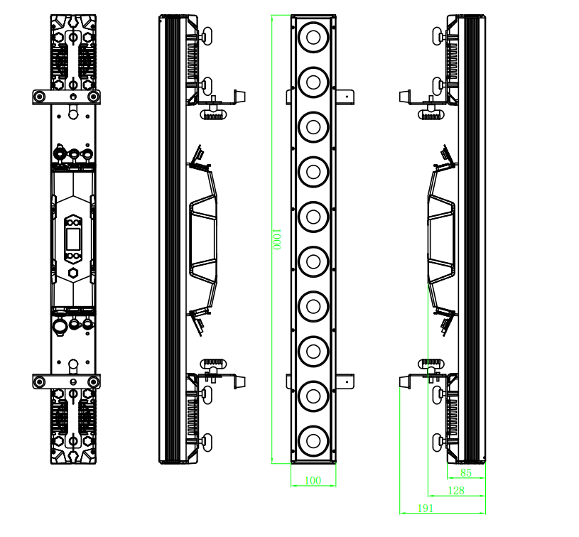
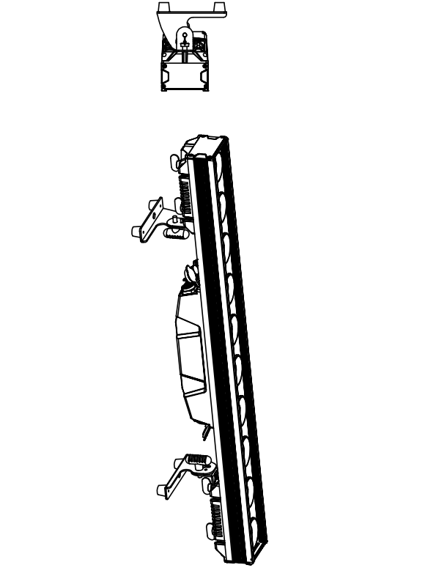

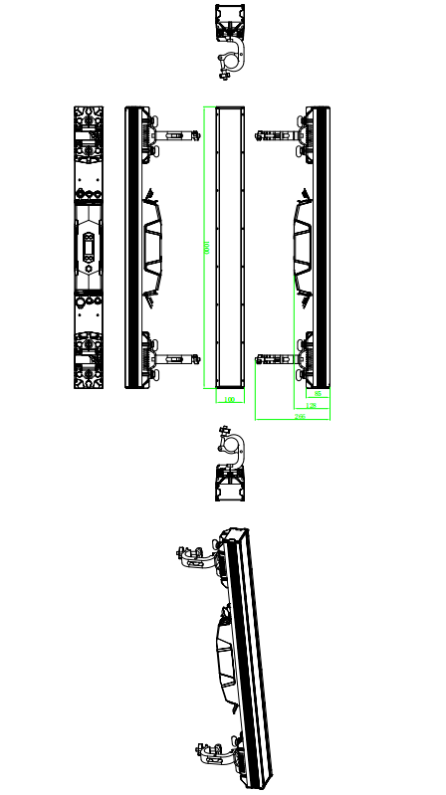

6.Trouble Shooting
Following are a few common problems that may occur during operation. Here are some suggestions for easy troubleshooting:

A. The unit does not work, no light and the fan does not work
1. Check the connection of power and main fuse.
2. Measure the mains voltage on the main connector.
3. Check the power on LED.

B. Not responding to DMX controller
1. DMX LED should be on. If not, check DMX connectors, cables to see if link properly.
2. If the DMX LED is on and no response to the channel, check the address settings and DMX polarity.
3. If you have intermittent DMX signal problems, check the pins on connectors or on
PCB of the unit or the previous one.
4. Try to use another DMX controller.
5. Check if the DMX cables run near or run alongside to high voltage cables that may cause damage or interference to DMX interface circuit.
C. One of the channels is not working well
1. The stepper motor might be damaged or the cable connected to the PCB is broken.
2. The motor’s drive IC on the PCB might be out of condition

7.Fixture Cleaning
The cleaning of internal and external optical lenses and/or mirrors must be carried out periodically to optimize light output. Cleaning frequency depends on the environment in which the fixture operates: damp, smoky or particularly dirty surrounding can cause greater accumulation of dirt on the unit’s optics.
• Clean with soft cloth using normal glass cleaning fluid.
• Always dry the parts carefully.
• Clean the external optics at least every 20 days. Clean the internal optics at least every 30/60 days.

